MODULE 1A PART CH: STUDENT FACTSHEET – WHY BEEF IS PRODUCED IN CERTAIN REGIONS

The main sources of nutrition for the beef industry are grasslands and concentrates from cereal crops. The ability to grow grass or cereal crops has an effect on the locations of beef systems, mainly because of economic reasons relating to food costs. The cheapest nutrional sources for ruminants are grass and cereal crops, both high in protein and energy.
Grasslands are one of the most extensive ecosystems, and cover 35 000 000 km² or 26% of the world’s surface and 70% of the agricultural surface [1]. Since there is no consistent definition of grasslands, this information is only approximate.
Naturally, ruminants are associated with the World’s grasslands. These can be divided into natural grasslands, semi-natural, and grasslands under controlled management.
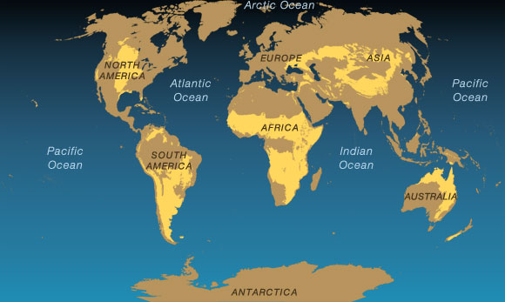
FigurE 1: GRASSLANDS OF THE WORLD
(http://environment.nationalgeographic.com/environment/habitats/grassland-map.html)
Additional tiers could be added to define grasslands, namely tropical grasslands and temperate grasslands.
 | NATURAL / SEMI-NATURAL  GRASSLANDS | CONTROLLED GRASSLANDS
TROPICAL GRASSLANDS | - Pampas of South America (north)  - Savannah in Africa | - Agricultural Grasslands
TEMPERATE GRASSLANDS | - Pampas of South America (south)  - Prairie of North America  - Steppes in Asia  - Uplands of Britain | - Agricultural Grasslands of Western Europe
TablE 1 : Division of grasslands
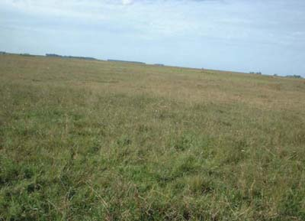
[Photo 1: Landscape of the Pampas tropical grasslands - natural/semi- natural]
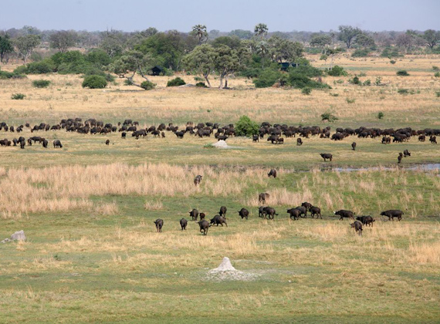
[Photo 2: Landscape of the Savannah tropical grasslands - natural]

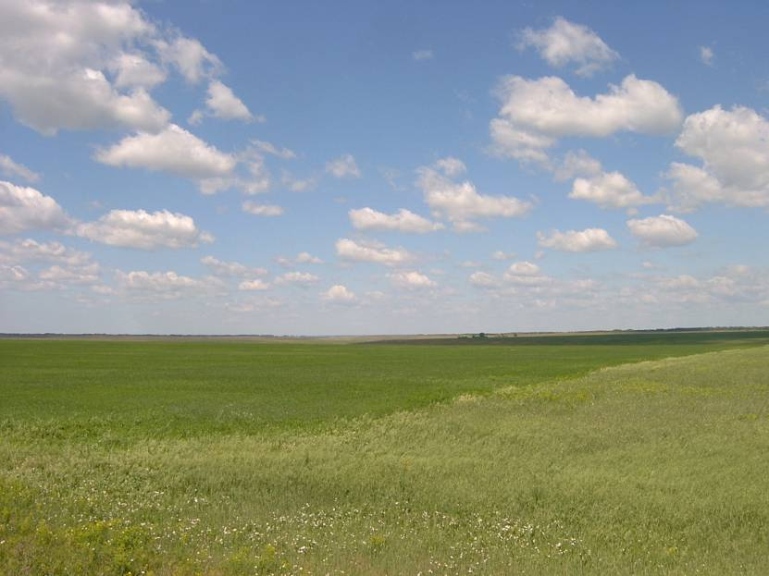
[Photo 3: Landscape of the Steppes temperate grasslands - natural/semi- natural]
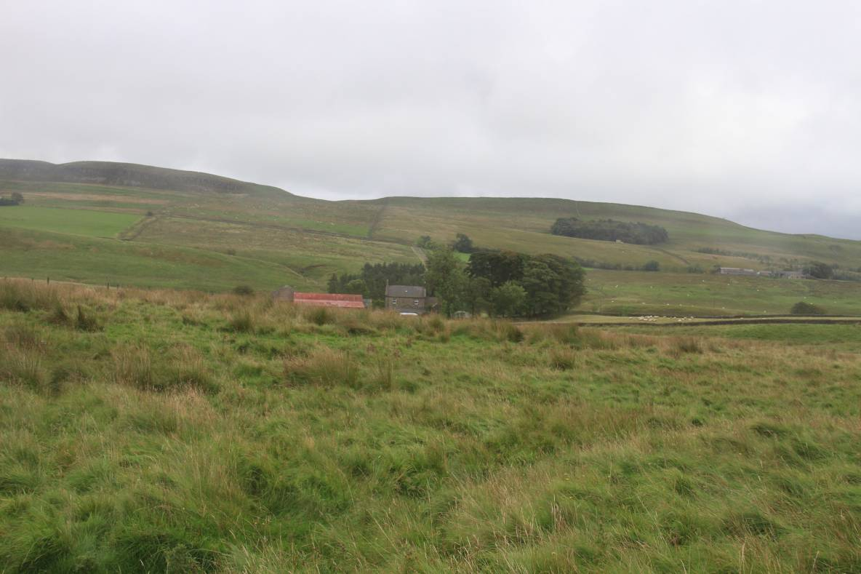
[Photo 4: Landscape of temperate grasslands – semi-natural]

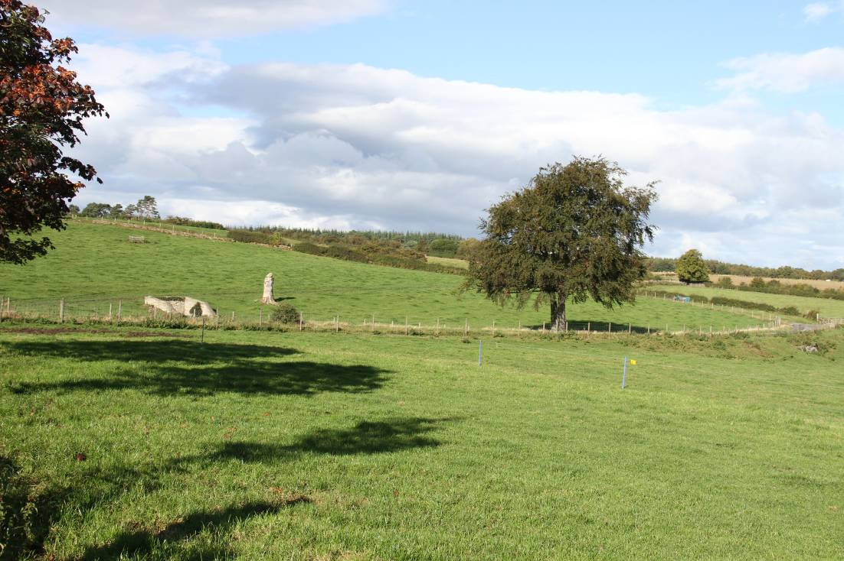
[Photo 5: Landscape of temperate grasslands – controlled]

A variety of grass species and grassland plants can be seen on every continent. Weather and climate are also deciding factors in whether the ecosystems are natural or under agricultural control, and contribute to variable production. Main factors affecting growth are temperature, rainfall and plant species.

Location of britain’s beef industry
Britain produces about 880,000 tonnes of beef yearly from two main sources namely, the milking herd and the suckler herd. Climate influences the locations of beef systems.
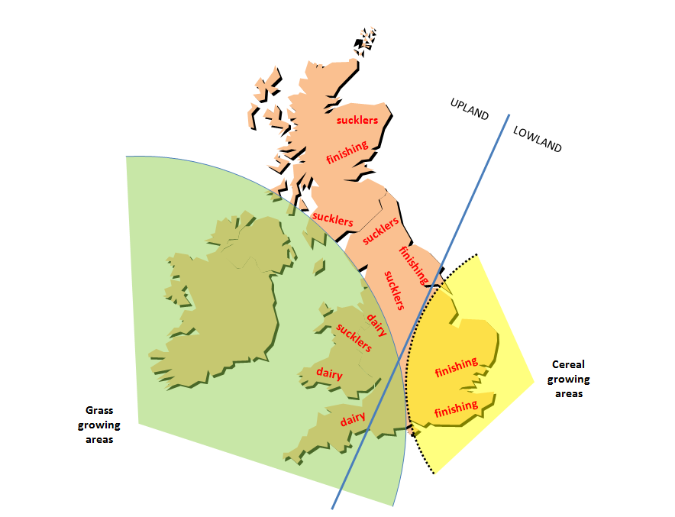
Figure 2 : Locations of beef systems in Britain
Since grass is an inexpensive feed for ruminants, systems that produce animals are mainly on the western grasslands, and systems that finish cattle nearer the cereal cropping regions. The higher cost of transporting grain to western areas is an important economic factor in deciding the location of a finishing system.
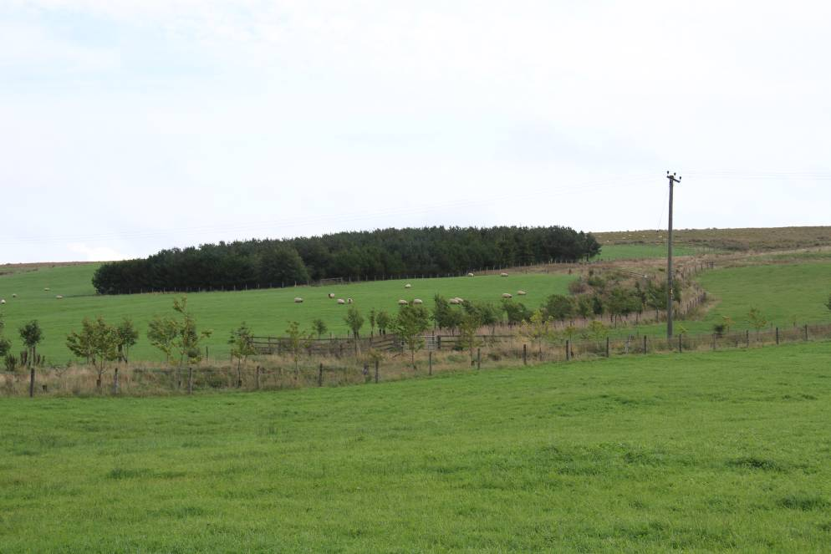
[Photo 6: Landscape of a grass growing region]
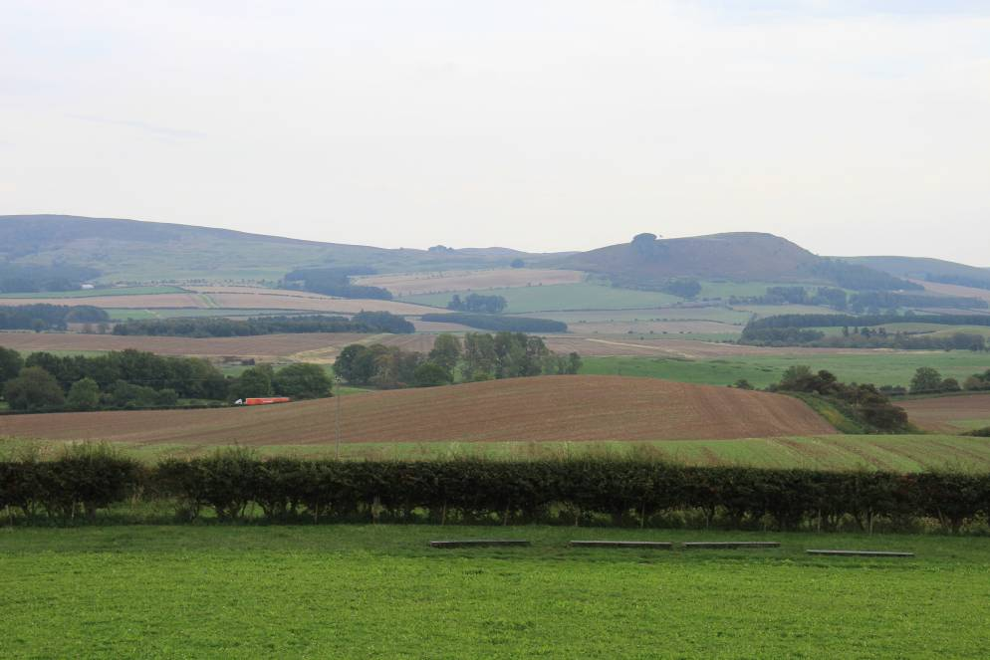
[Photo 7: Lanscape of a mixed farming region, showing grasslands and cereal crops]
The effect of climate on location of beef systems in Britain
The weather comes to Britain from the Atlantic Sea in the South West. This means that the regions towards the South and West
- receive more rain
- have less hours of sunshine, and
- are warmer in winter, but cooler in summer
than the lands in the East. The temperature in the West is frequently higher than 6 degrees Celsius, allowing the grass to grow throughout the year.
The drier spells and more hours of sunshine in the East are an advantage to grain growers, who need a substantial growth period in summer and dry weather to harvest the crop before the Autumn. Therefore, ruminants are more likely to be predominant in agricultural systems in Western Britain, and the systems that use concentrates to finish animals are more likely to be predominant in the East.
Rainfall
On comparing the rainfall of three locations of similar latitude (Aberporth, Stratford upon Avon and Wattisham), the total rainfall in the West over twelve months is higher, because it received more rainfall during the winter months (Figure 3 and figure 4). High rainfall prevents land use during the winter months, and, very often compel farmers to keep their animals indoors. In addition, high rainfall during the summer months in the West means that the grass grows constantly during these months.

Temperature
Temperature in the West (Aberporth) is warmer in winter than in Wattisham, but cooler in summer because of the sea’s influence (cooling the land) (Figure 5). Therefore, grasslands have an extended period of growth in winter. This is advantageous to systems that depend more on grass as their principal nutritional feed.

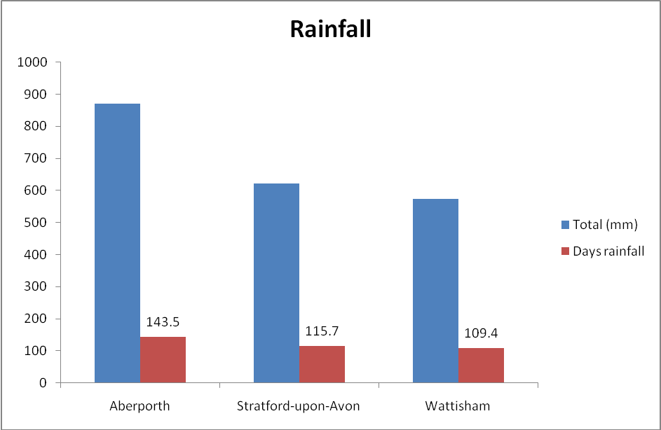
Figure 3 Total rainfall and number of days of rain
http://www.metoffice.gov.uk/climate/uk/
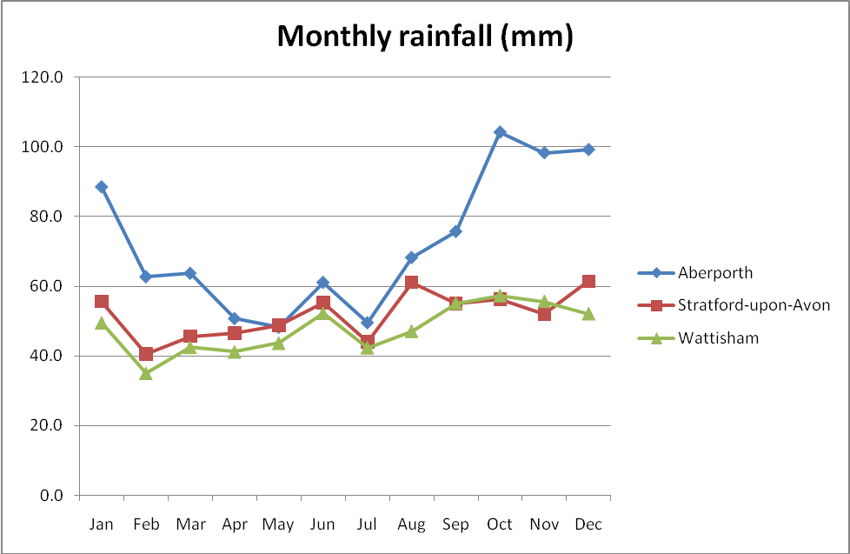
figure 4 Distribution of rainfall IN 3 locations FOR each month of the year
http://www.metoffice.gov.uk/climate/uk/

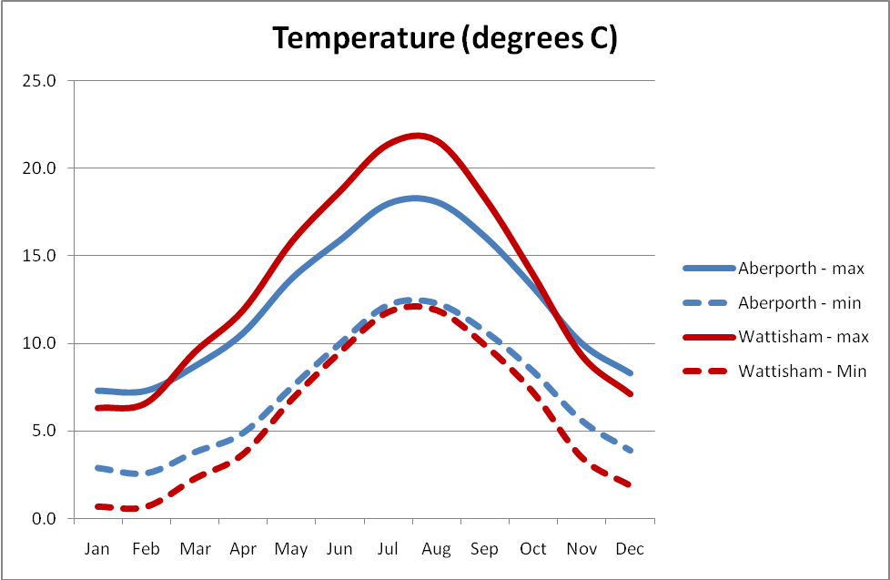
Figure 5 Temperature of Aberporth v Wattisham
http://www.metoffice.gov.uk/climate/uk/

CLIMATE CHANGE
Western Britain has a damp, temperate pattern of growth, but climate change could bring a more Mediterranean-like pattern to Eastern Britain because of dry weather during the summer months and mild weather during the winter months.

shows some growth patterns World-wide. The present systems have been adapted to accommodate climate variations, but with climate change, the present beef producing systems will need to be modified.

Seasonal Grassland growth patterns in several climate zones (adaptation of Snaydon 1981)
Summer
Autumn
Winter
Spring
Tropical
Mediterranean
Sub-tropical
Continental
Moist temperate

Figure 6 seasonal growth patterns

seasonal growth patterns – dry matter production
 | Tropical | Sub-tropical | Continental | Mediterranean | Temperate,  humid
Spring |  |  | ● |  | ●
Summer |  |  |  | ○ | 
Autumn |  |  | ● |  | 
Winter |  |  | ○ |  | ●
Notes | Constant high-quality produce throughout the year because of humidity and higher temperature | Higher quality produce, but less during spring and winter when the temperature is lower. | Short growing season during summer, and no growth during the cold winter months. | Two growth peaks in spring and autumn, but not in summer due to dry weather. | Growth from spring to autumn when the temperature is higher than 6 degrees Celsius.

References
Panunzi, E. Are grasslands under threat? Brief analysis of FAO statistical data on pasture and fodder crops. 2008 [cited 2009 6/7/2009]; Available from: http://www.fao.org/ag/agp/agpc/doc/grass_stats/grass-stats.htm.
Snaydon R W The ecology of grazed pastures In Morley FHW ed Grazing Animals Elsevie pp 13-31
GRASSLANDS of the WORLD Edited by J.M. Suttie, S.G. Reynolds and C. Batello FOOD AND AGRICULTURE ORGANIZATION OF THE UNITED NATIONS ROME 2005 http://www.fao.org/docrep/008/y8344e/y8344e00.htm#Contents

